Similar Exercises:
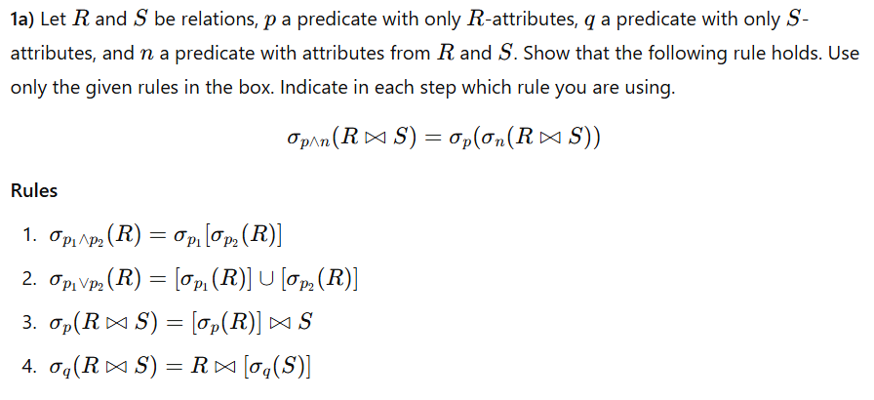

Similar Exercises 2:
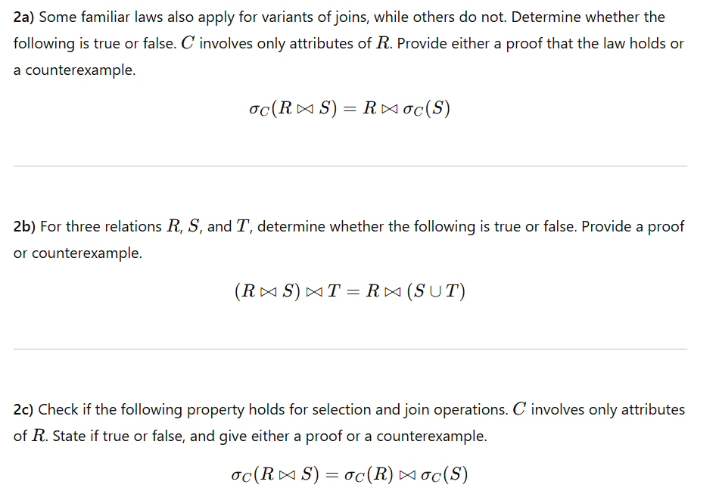

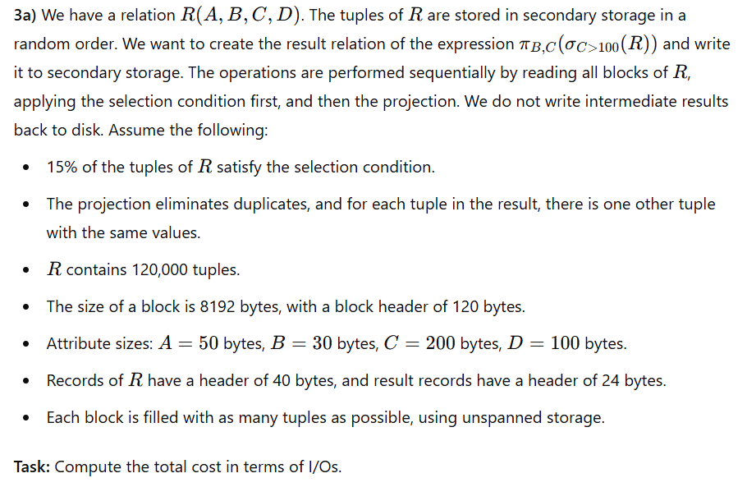
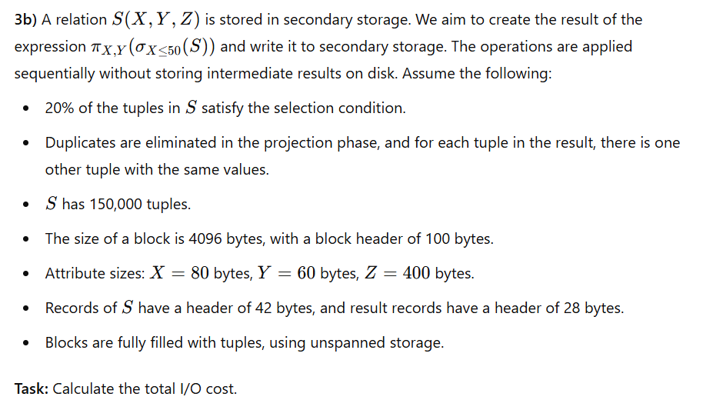
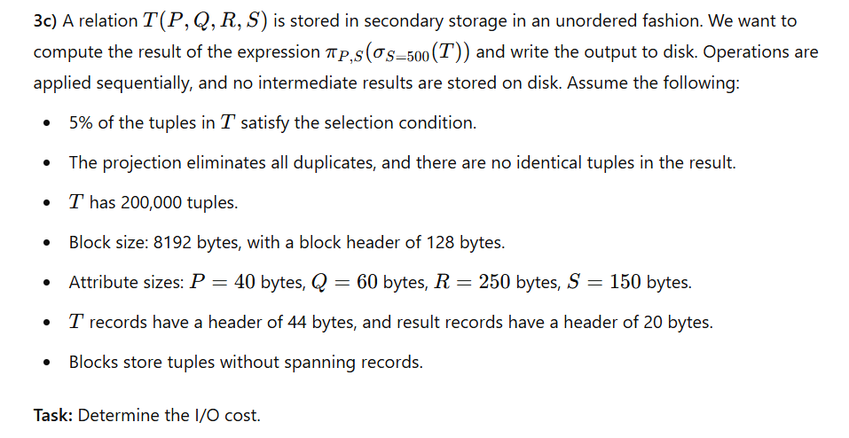

3a) We have a relation S(X, Y, Z, W) stored in secondary storage in a random order. We want to create the result relation of the expression π_Y,W (σ_X>50(S)) and write it to secondary storage. The process involves sequentially reading all blocks of S, applying both operations without writing the intermediate relation to disk, and finally writing the blocks of the result relation to disk. We assume that 15% of the tuples in S satisfy the selection condition and that for each tuple in the result relation, there is one duplicate tuple. The following information is given:
- S has 200000 tuples.
- The block size is 8192 bytes with a block header of 120 bytes.
- The attribute sizes are X: 64 bytes, Y: 32 bytes, Z: 256 bytes, W: 160 bytes.
- Records of S have a header of 42 bytes, and records of the result relation have a header of 24 bytes.
- Each block is packed with as many tuples as possible using unspanned storage.
What is the cost in terms of the number of I/Os?

3b) We have a relation T(P, Q, R, S, T) stored in secondary storage. We want to compute the result relation of the expression π_P,S (σ_T<100(T)), applying the selection and projection before writing to secondary storage. The relation T is stored randomly, and no intermediate relations are written to disk. Assume that 5% of the tuples satisfy the selection condition and that there are two duplicates per unique tuple in the final result. The given information includes:
- T has 500000 tuples.
- The block size is 8192 bytes with a block header of 100 bytes.
- The sizes of attributes are P: 48 bytes, Q: 64 bytes, R: 128 bytes, S: 32 bytes, T: 256 bytes.
- Records of T have a 40-byte header, and records in the final result have a 20-byte header.
- Blocks hold as many records as possible, and storage is unspanned.
What is the cost in terms of the number of I/Os?

3c) We have a relation U(V, W, X, Y, Z) stored in secondary storage in random order. We want to create the result relation of the expression π_W,X (σ_V≤500(U)) and write it to secondary storage. The process reads all blocks of U sequentially, applies the selection and projection, and writes the result directly to disk. Assume that 20% of tuples satisfy the selection condition and that each unique tuple appears twice in the final result. The following information is provided:
- U contains 750000 tuples.
- The block size is 8192 bytes, and the block header size is 130 bytes.
- Attribute sizes: V: 96 bytes, W: 48 bytes, X: 192 bytes, Y: 64 bytes, Z: 160 bytes.
- Records of U have a 36-byte header, and records in the result relation have a 26-byte header.
- Storage is unspanned, and each block is filled as much as possible.
What is the cost in terms of the number of I/Os?

Solution : 60,193 I/Os
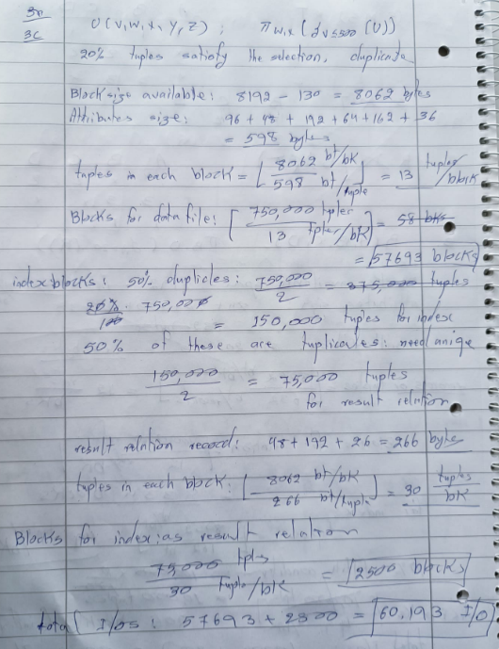

What’s going on in the question?
You are asked to evaluate the I/O cost of creating a result relation:

That means:
- Selection (σ A=20): Pick only those tuples from R where A=20.
- Projection (π B,D): From the selected tuples, keep only the attributes B and D. Also, eliminate duplicates.
- Write to disk: Store the result relation back into secondary storage.

Key Concepts You Need to Understand

1. Disk I/O is the bottleneck
- In database systems, the dominant cost is reading/writing blocks from disk (not CPU or memory).
- That’s why the exam question only asks about number of I/Os (block reads and writes).

2. Records and blocks
- A block has a fixed size (e.g., 8192 bytes here).
- Each record has a size (attributes + record header).
- Because storage is unspanned (in your question), each record must fit entirely inside a block.
- So:
  - You calculate how many records fit per block = floor(usable_bytes / record_size).
  - Then the number of blocks for a relation = ceil(num_records / records_per_block).
This explains why we first calculated tuples per block for R and blocks to hold R.

3. Sequential scan cost
- To apply selection, you usually do a full table scan (since tuples are in random order and no index is given).
- Cost = number of blocks in R.
- Example: If R = 8334 blocks, then selection must read 8334 blocks.

4. Selection reduces number of tuples
- After reading R, you know what fraction of tuples satisfies the condition (A=20).
- Here, 10% of 100,000 = 10,000.
- This is important for output size and later cost (projection and writing).

5. Projection and duplicate elimination
- Projection reduces the tuple width (number of attributes).
- Here we drop A and C, keep only B and D.
- This changes the record size → so we must recompute how many tuples fit per block.
- Duplicate elimination: here you’re told each tuple pairs with a duplicate, so the final output is half the selection size (5,000).

6. Writing results to disk
- Once you have the final tuples, you must write them into blocks.
- Same rule: compute tuples-per-block for the result, then divide and round up.
- Writing cost = number of result blocks.

7. Intermediate materialization vs pipelining
- Two strategies exist:
  - Pipelining (as in your question):
    - Read R, apply selection + projection in memory, write only the final result.
    - Cheaper: only read R once and write the final relation once.
  - Materialization:
    - Write intermediate results (e.g., selection output) to disk, then read them back for projection.
    - More expensive because of extra read + write I/Os.
- The exam tests if you understand that avoiding intermediate writes reduces I/O cost.

Summary of the Concept
- Step 1: Compute how many tuples fit per block (record size vs block size).
- Step 2: Estimate number of blocks for R.
- Step 3: Full scan = cost = blocks of R.
- Step 4: Apply selection → reduces number of tuples.
- Step 5: Apply projection → reduces record width and number of tuples (with duplicate elimination).
- Step 6: Compute blocks needed for the final relation, and that many I/Os to write it.
- Step 7: Add it up: I/O = reads + writes.
- Extra note: If you had to write intermediate results (instead of pipelining), cost increases a lot.

Solutsion: I/O totals & step-by-step breakdowns for each case.
Common data (re-used in all variants)
- |R| = 100000 tuples.
- Block size = 8192 bytes → payload per block = 8192 − 140 = 8052 bytes.
- R record size = A(84)+B(20)+C(370)+D(120) + rec_header(38) = 632 bytes.
- Result record (B,D) size = 20 + 120 + rec_header(22) = 162 bytes.
- Selection selectivity: 10% → selected tuples = 10000.
- Duplicate information: selected projected tuples pair up → final unique tuples = 10000 / 2 = 5000.
- Unspanned packing: use whole records per block (no record crosses block boundaries).
- Spanned packing: records may cross blocks (we compute by total bytes / payload).
I computed all numbers exactly; below are the useful derived values used in totals:
- usable payload per block = 8052 bytes.
- tuples-per-block (R, unspanned) = floor(8052 / 632) = 12 → 12 tuples/block.
- blocks for R (unspanned) = ceil(100000 / 12) = 8334 blocks.
- blocks for R (spanned) = ceil(100000 * 632 / 8052) = 7849 blocks.
- blocks for selection (10000 tuples):
  - unspanned: ceil(10000 / 12) = 834 blocks.
  - spanned: ceil(10000 * 632 / 8052) = 785 blocks.
- result tuples = 5000 (after duplicate elimination). Blocks for final result (5000 tuples):
  - unspanned: floor(8052 / 162) = 49 tupl/block → ceil(5000/49) = 103 blocks.
  - spanned: ceil(5000 * 162 / 8052) = 101 blocks.
- result without duplicate elimination (10000 projected tuples) blocks:
  - unspanned: ceil(10000 / 49) = 205 blocks.
  - spanned: ceil(10000 * 162 / 8052) = 202 blocks.

Scenarios & I/O costs (reads + writes)
- Baseline you already had — single scan of R, apply selection + projection in memory (no intermediate write), unspanned storage
  - Read R: 8334 reads
  - Write final result (5000 tuples): 103 writes
  - Total I/Os = 8334 + 103 = 8,437 I/Os
- Same as (1) but spanned records allowed (often slightly better)
  - Read R (spanned): 7,849 reads
  - Write final result (spanned 101 blocks): 101 writes
  - Total I/Os = 7,849 + 101 = 7,950 I/Os
- No duplicate elimination (i.e., projection keeps all 10,000 tuples) — unspanned
  - Read R: 8,334 reads
  - Write final result (10,000 tuples → 205 blocks): 205 writes
  - Total I/Os = 8,539 I/Os
- No duplicate elimination — spanned
  - Read R: 7,849 reads
  - Write final result (202 blocks): 202 writes
  - Total I/Os = 8,051 I/Os
- Materialize intermediate selection to disk (unspanned)
Workflow: read R → write selection relation (materialize) → read selection back → produce projection & write final result.
  - Read R: 8,334 reads
  - Write selection (10000 tuples, unspanned): 834 writes
  - Read selection: 834 reads
  - Write final result (duplicate-elim → 5000 tuples): 103 writes
  - Total I/Os = 8,334 + 834 + 834 + 103 = 10,105 I/Os
- Materialize selection — spanned packing for everyone
  - Read R (spanned): 7,849 reads
  - Write selection (spanned): 785 writes
  - Read selection: 785 reads
  - Write final result (spanned 101 blocks): 101 writes
  - Total I/Os = 7,849 + 785 + 785 + 101 = 9,520 I/Os
- Materialize selection then project without duplicate elimination (unspanned)
  - Read R: 8,334 reads
  - Write selection: 834 writes
  - Read selection: 834 reads
  - Write final (no dedup) 10,000 tuples → 205 writes
  - Total = 8,334 + 834 + 834 + 205 = 10,207 I/Os
- Materialize selection then project without dedup (spanned)
  - Read R: 7,849 reads
  - Write selection: 785 writes
  - Read selection: 785 reads
  - Write final (spanned 202 blocks): 202 writes
  - Total = 9,621 I/Os

Quick comparison & recommendations
- Cheapest among these: apply selection + projection in memory, with spanned records → 7,950 I/Os (scenario 2). If spanned is not allowed, applying both in-memory with unspanned is next best: 8,437 I/Os (scenario 1).
- Materializing the intermediate selection is expensive — it adds two I/O passes over the selection (write it, then read it), increasing cost by thousands of I/Os. Avoid materialization unless you must (e.g., not enough memory to perform projection/deduplication in-memory, or you need the intermediate for recovery / other queries).
- Duplicate elimination saves significant disk writes here (103 vs 205 blocks), so if you can deduplicate in-memory (or via an internal algorithm that minimizes writes), do it.

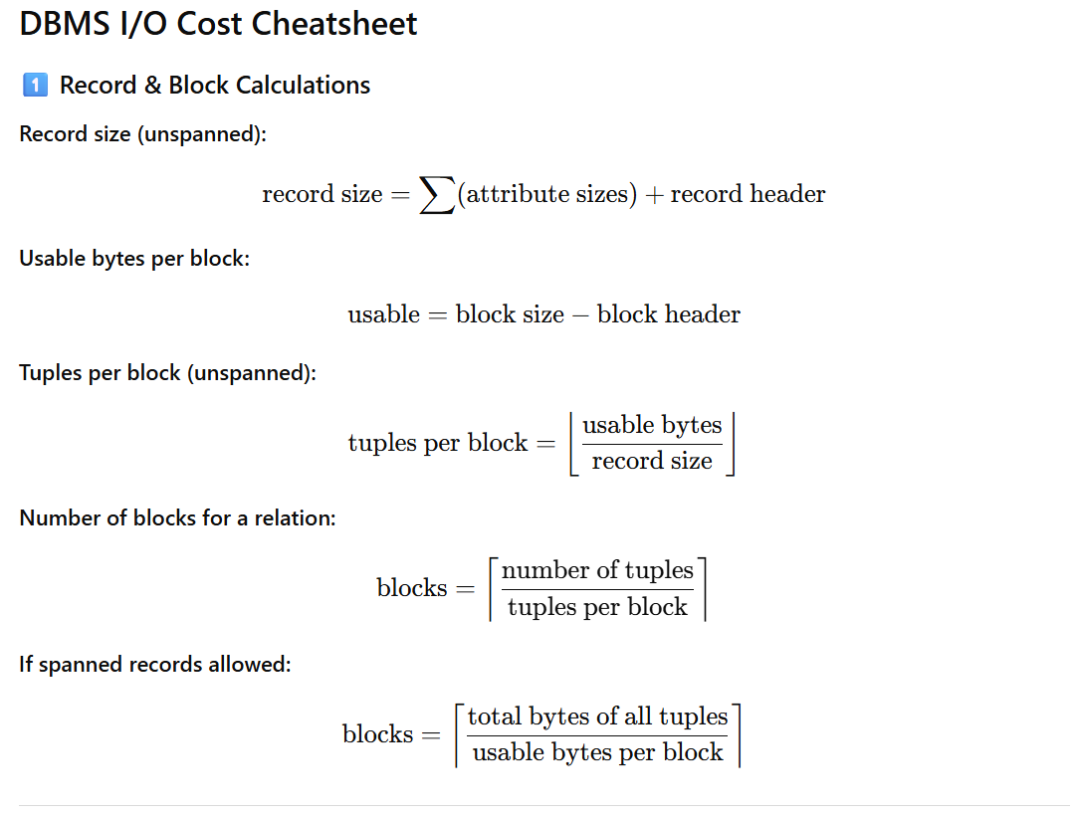
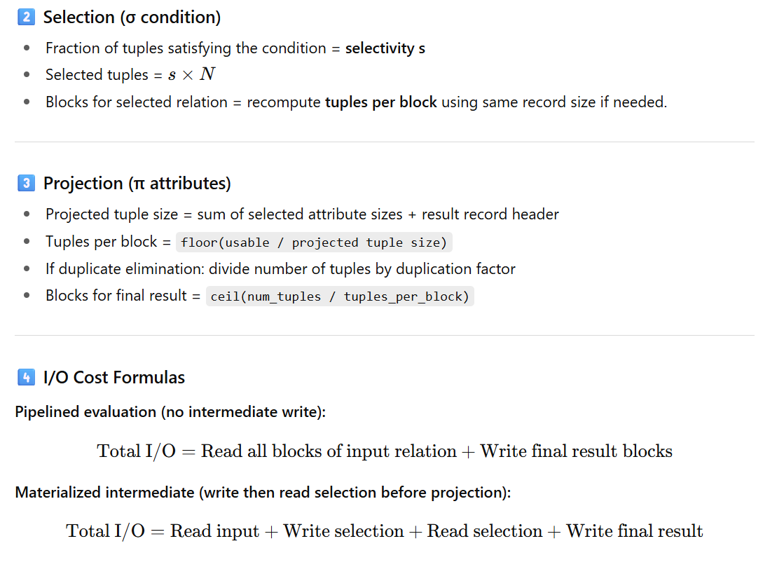

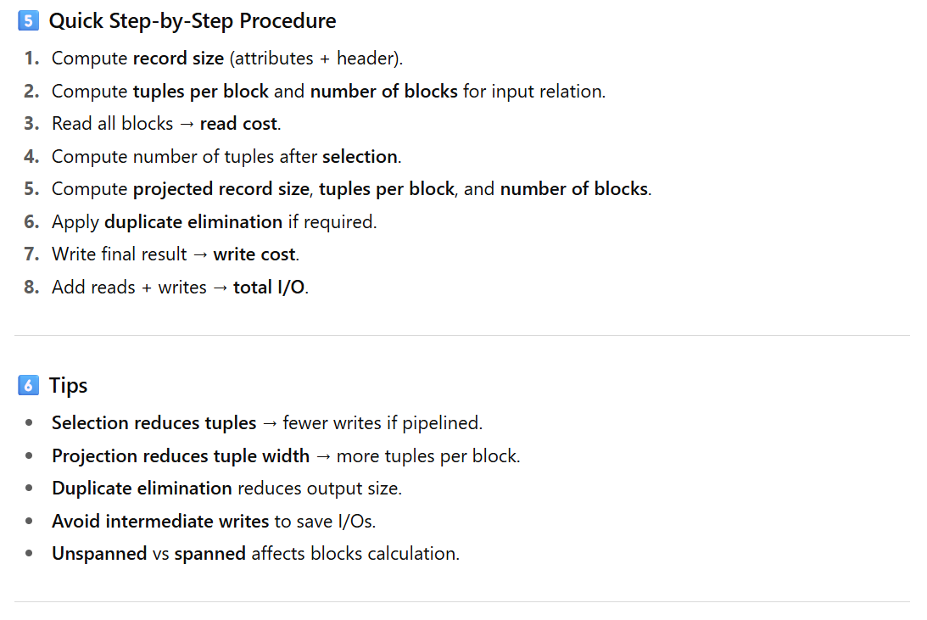

Below are some exam-style questions you can use that are consistent with — and at a similar difficulty level as — the ones in your exercise sheet.

🧩 Exam Question 1 — Relational Algebra Law Application
Let relations R(A, B) and S(B, C), and predicates p, q, m be defined such that
- p only involves attributes of R,
- q only involves attributes of S, and
- m involves attributes from both R and S.
(a) Using the standard relational algebra laws (selection pushdown and distributivity), prove the following equivalence:
σ_{m∧p∧q}(R ⋈ S) = σ_m(σ_p(R) ⋈ σ_q(S))
Indicate in each step which rule you are using from the given rule set.
(b) Explain intuitively why this optimization is beneficial for query processing.

🧩 Exam Question 2 — Outer Join and Selection Rules
Given relations R(X, Y), S(Y, Z), and T(Z, W):
a) Is the following equivalence true for outer joins? If yes, prove it; if not, provide a counterexample.
σ_{Y>5}(R ⟖ S) = σ_{Y>5}(R) ⟖ S
b) Is the following associative law valid for outer joins? Justify your answer with proof or a counterexample:
(R ⟖ S) ⟖ T = R ⟖ (S ⟖ T)

🧩 Exam Question 3 — Query Cost Estimation
Relation R(A, B, C, D) has 80,000 tuples stored on disk in random order.
You must evaluate and materialize the result of the query:
The following information is known:
- Block size: 8192 bytes, header = 140 bytes.
- Attribute sizes: A = 80 bytes, B = 30 bytes, C = 300 bytes, D = 100 bytes.
- Record header: 38 bytes.
- Result relation record header: 22 bytes.
- 10% of tuples satisfy A=50.
- The projection eliminates duplicates, and for every surviving tuple, there is one duplicate (so size reduces by 50%).
- Unspanned storage is used.
Tasks:
- Compute the number of tuples and blocks in the selection result.
- Compute the number of tuples and blocks in the final projected result.
- Estimate the total I/O cost (number of block reads + writes).

🧩 Exam Question 4 — Optimization Plan Comparison
Relations R(a, b) and S(b, c) each have duplicates; attribute b takes values 1–20 uniformly.
Each tuple appears, on average, three times.
We want to find, without duplicates, all tuples in (R ⋈ S) with (b=5).
Consider three alternative query plans:
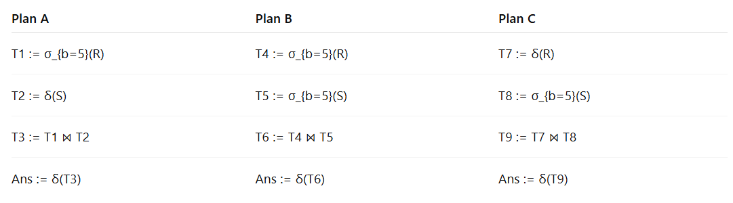Question:
For each plan, derive a formula for the expected sum of sizes of all intermediate relations, expressed in terms of (r) and (s), and identify which plan minimizes the total cost.

